**Design Assignment - 1**

Team Name: TeamName

**NUID/ Name** , *Work distrubution*:

1. **001304148/ Lin, LiangYen**, *Explanation of the system and dashboards*

2. **001304955/ Tsai, YuTing**, *Sequence diagram and explanation of sequence diagam*

3. **001372878/ Kuo, DahWei**, *Object diagram and explanation of object diagram*

Outline:

Explanation of the system -> Object diagram -> Dashboards ->

Sequence diagram -> Conclusion

**Explanation of the system:**

The main goal of this system is to improve the quality of education, and make the educational system better for the future generations. Besides, by linking the courses and the salary, we can also see the relationship between academic system and industries. To achieve these goals, we designed a ranking system to measure the relationship between courses and the salary of the students who have taken these courses after their graduation. Here’s how the ranking system works:

First, we can gather the following data of graduated students from the school:

1. Student’s Name.
2. All courses they’ve taken ( with the name of the professor who taught that course).
3. GPA of every course they’ve taken, which could represent the performance of a student in the particular course.
4. The jobs they’re doing, and whether the job they’re doing is related to the student’s major or not.
5. Their salary of the 1st and 5th year after graduation.

After gathering these data, we can calculate the salary growth over a 5-year period. The growth of their salary is highly related to the promotions of their career. So we use their salary growth to represent their promotions.

In the VIEW page, we can check the data that user have input before in a table. In case the users might’ve input the wrong data or students might’ve report the wrong data, users are also allowed to update and delete the data of students in the VIEW page.

Besides, we’ll also add COURSES and VIEW COURSES page, which allow users to create courses, with the name of the professor who taught the course along with it. This allow users to create/view all courses provided by the university.

|  |  |  |  |  |  |  |
| --- | --- | --- | --- | --- | --- | --- |
| Rank\ Object | Course | 1st Avg. Sal.  RK Score | 5th Avg. Sal  RK Score | Growth(Promotion)  RK Score | Professor  RK Score | Total score  (General) |
| No.1 |  |  |  |  |  |  |
| No.2 |  |  |  |  |  |  |
| No.3 |  |  |  |  |  |  |

Finally, there will be a VIEW RANKING page, which is the part that we can see the quality of the courses. In this page, the table will look like:

The “Rank” column will not change with actions. Yellow part of the form will be buttons. Pressing each button will display the different type of ranking of the courses (as shown in the form).

However, in a lot of cases, the quality of the courses cannot simply represented by the salary or growth of the salary. So we created our unique method, which is presented as Ranking Score to rank the courses. Here’s how we calculate the Ranking score of a course :

**Ranking Score=**

$\frac{(Yearly Salary)*GPA\left(of 1st \right)+(Yearly Salary)*GPA\left(of 2nd\right)+…}{n}$

( GPA(1st)= GPA of 1st student, n = number of students in that course )

The user should input the data of a graduated student, which included GPA of each course. The reason we ask for GPA is that a student’s grade can measure their performance in class. If a student did well and get an A in class, that means he/ she spent time and worked hard on that course, it also mean that the course will have a great influence on the student. On the other hand, if a student only get a C in the class, it means that the student was not willing to spend time, or even hated that class. In that case, the student is not affected strongly by that course. So a student’s salary of 1st and 5th year is multiplied by GPA. In another word, if a student has a high salary, but he/ she did pretty bad on MATH course, that mean MATH course should not be considered as one of the reasons for her success in industry.

After a student’s 1st and 5th year is multiplied by GPA, we add up every student’s data, and divided by the number of the students in that course. And generate different types of Ranking Score of the course, which is the main calculating mechanism of our ranking system.

*In the beginning, we’ve asked the user to input whether a graduated student’s job is related to their major or not. The reason we design this mechanism is because exceptions always happen. Let’s say a student who majored in computer science, had an average performance on each course, suddenly becomes a famous actor a year after graduation, and made plenty of money each year. In that case, the salary and salary growth should not have impact on the course’s Ranking Score because his/ her job is totally non- related to his/ her major. So we decide to take exceptions out of the Ranking Score calculating system,* to prevent some extreme/ exception cases. Once the job they’re doing is utterly not related to their field of study, we simply take those cases out of the Ranking Score formula.

Besides, we also consider whether a student keep pursuing a higher educational degree or not. If yes, then it should also be an exception case, because the student is not in the industry yet, he/ she might just had a part-time job for his/ her living expenses. On the other hand, if a student do not pursue a higher degree, still don’t have a job, we’ll still consider it into the calculating system, and the student’s salary is zero.

After considering exception cases, the Ranking Score can be adusted to:

$\frac{(Yearly Salary)*GPA\left(of 1st \right)+(Yearly Salary)*GPA\left(of 2nd\right)+…}{n-(the amount of exception cases)}$

(then exception cases will be eliminated) . And this is the final version of our Ranking Score calculating method. The same method can also be used to calculate a professor’s Ranking Score.

**Object Diagram:**

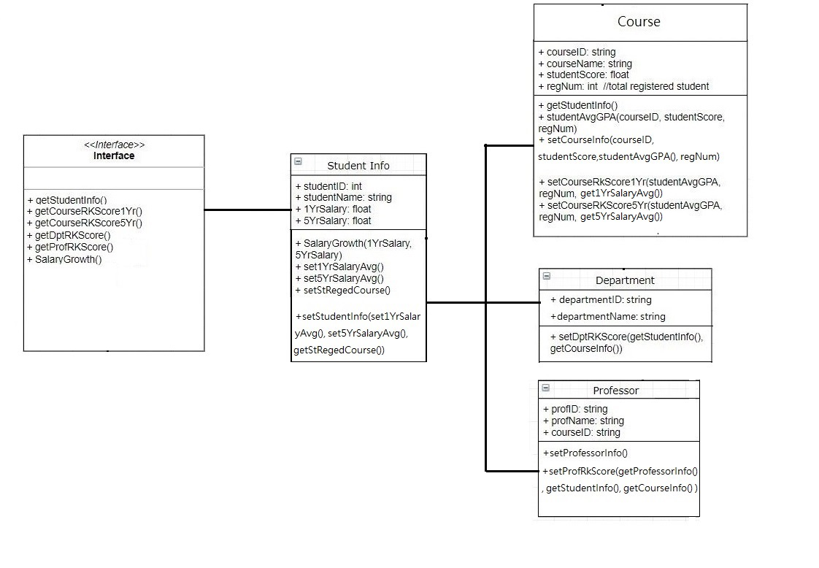

As mentioned above, to measure a student’s performance in class, we should look at the student’s salary after graduation. We can achieve a student’s information (salary, course, GPA) from the backend database. Then calculate the growth of their salary, and set as a new database (setStudentInfo).

As the Course object, we can achieve the basic data of the course from schools (setCourseInfo), then compare it to the data of student’s salary (in setStudentInfo). So we can use the GPA and the salary of 1st and 5th year of a student who has taken this course, to calculate the ranking of the course. In course object, the regNum is the number of students that have taken this course, so we can calculate the ranking score in our system.

The same method can be applied to Department and Professor Section, the only difference is the target we focus on. By achieving data from Course, we can achieve the score of different departments and professors.

**DashBoards:**

**1. Course vs course in a same department**

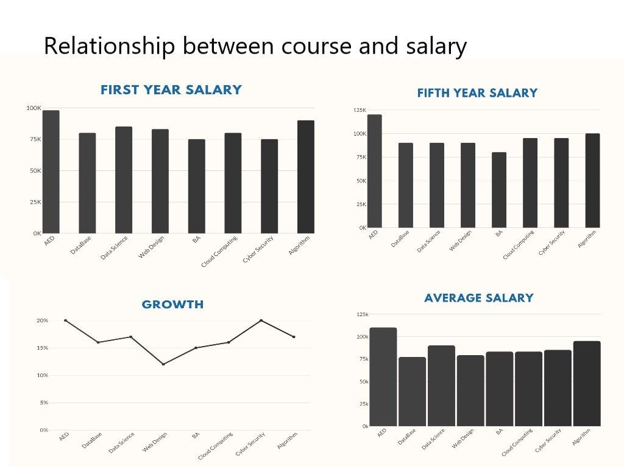

**2. department vs department**

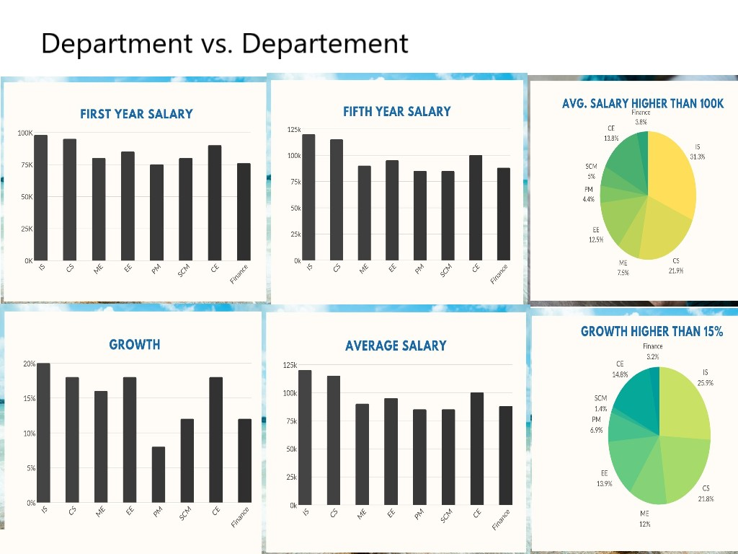

**3. Students**

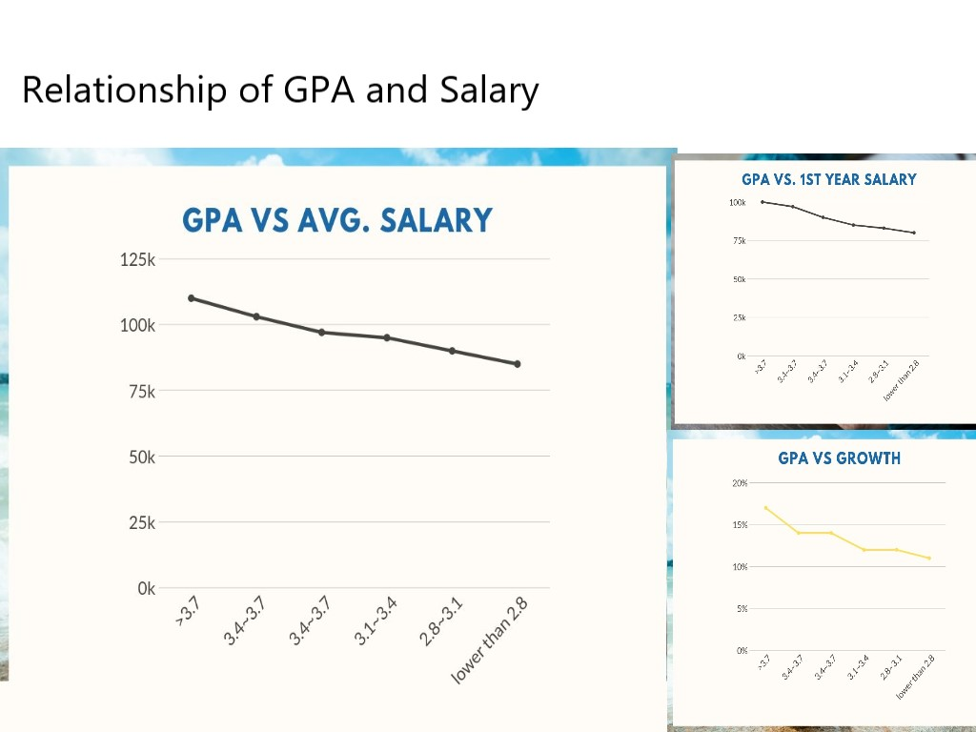

**Sequence Diagrm:**

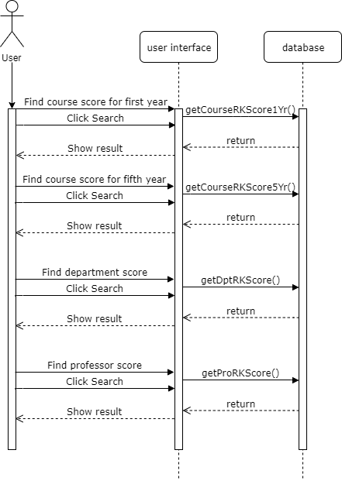

In the sequence diagram, user can achieve different types of Ranking Score, including Course Score, Department Score and Professor Score from the database of the school. By achieving these scores, users can easily understand the quality of their academic education, and figure out their own way to improve the quality of courses and department. Thus, we believe that with the assistance of this system, students in the later generations will have a great chance to receive a better quality of education and academic environment.

**Conclusion:**

As Professor Bugrara mentioned, calculation is not important. The reaon we demonstrate our calculation is to explain the mechanism of the system. At the end of the day, the only one thing that matters is whether a student, a course or a professor’s performance are great or not. By using our system, we can easily see the relationships between a course and a student’s career, the relationship between a professor and a student’s performance, and the relationship between a department and a student.

Well, let’s look at the student’s part first. How do we know a student’s career is successful? Just look at their salary and salary growth over five years, if both factors are in top 10% of the whole school (which can be achieved from school’s database), we know that the student made it! And how do we know whether a education environment is great or not? Just look at the view page, once the Ranking Score is on top 3 position, the course (professor, department) can be considered as one of the greatest academic education environment in this generation. With these results and the mechanism we created, we can say that our system works! Not only it works, it can also improve the education environment for the latter generations!